Computer Modelling - Unit 3

Task 4.2
Distance using rectangle at 10000 steps: 3212.1457296019194
Distance using trapezoid at 10000 steps: 3212.0557839189014
Distance using Simpson’s at 10000 steps: 3212.055783501712

Number of steps | Rectangle Rule | Trapezoid Rule | Simpson Rule
100 | 3221.0545231663673 | 3212.0600395537654 | 3212.0557834801994
1000 | 3212.9552820453805 | 3212.055825297954 | 3212.055783501698
10000 | 3212.1457296019194 | 3212.0557839189014 | 3212.055783501712
100000 | 3212.064778074204 | 3212.055783505873 | 3212.055783501665

Target Accuracy: Distance to Andromeda galaxy can be measured with a 4% uncertainty at a distance of about 0.8Mpc [Distance to the Andromeda galaxy from eclipsing binaries, F. Vilardell et al, Astronomy&Astrophysics, 21/01/10]. It is also worth noting that currently the Hubble constant H0 is known to about 1% uncertainty [The Hubble Tension, V.Poulin, CernCourier, https://cerncourier.com/a/the-hubble-tension/#:~:text=One%20of%20the%20main%20predictions,The%20Hubble%20tension%E2%80%9D%20figure). (accessed14/11/25)]. Considering this and the fact the distance to the examined galaxy is about 3200Mpc, 3 orders magnitude more than to Andromeda, I would estimate a target accuracy of 10^-3.
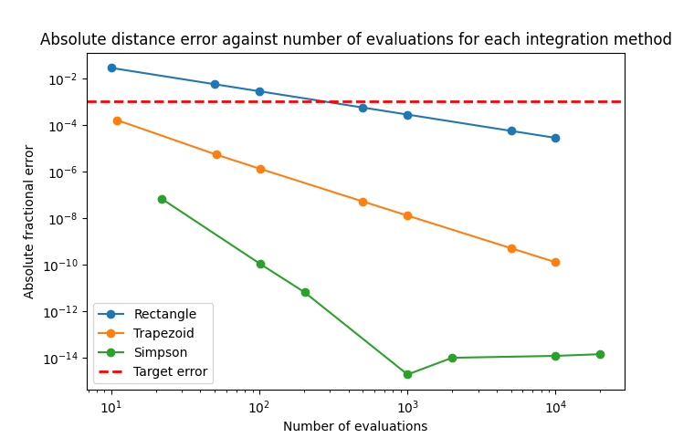
Recommended method: Using Simpson with 10^3 steps will give the lowest error for least evaluations, resulting in the most efficient calculation for the most accurate value.

Task 4.3
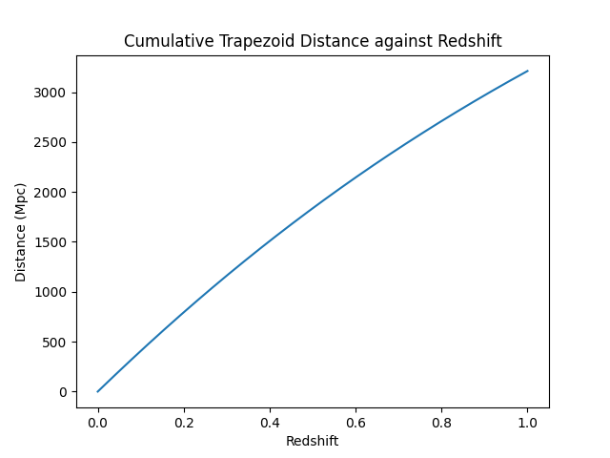

Task 4.4
